Installation Sheet - Item 1

Customer: REW Offer No: 4195A Group/Well: No.

Country: Czech Rebublic Quantity: 1-6 set Production: 200 m³/day

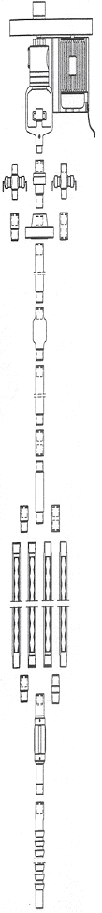
2.0 | SBS Drive Head | SBS DD  KB II 1.1
2.1.1 | Ex-proof Motor | 55 KW/1/  400V
2.2.2  2.2.5 | Power Cab  Stiering C. | 4x25mm²x15m  2x0,75mm²x15m
2.1.7 | 2nd Stuff Box | none
2.1.8 | BOP | BOP / Flow-T
2.1.6 | Adapter Drive Head | none
 | 3-1/2 EU  #9,2 | none
3.7 | Circulation Valve | none
 | 3-1/2 EU  #9,2 | none
3.2 | Adapter Pup Joint | none
3.1 | Pup Joint | none
3.3 | Adapter Stator | none
1.2  &  1.3 | PCP Stator  with  Stop Pin | SBS 120-060  (60-1200)  3-1/2” Box /  3-1/2” Pin
3.3 | Adapter Torque Anchor | ?
3.5 | Packer-  Torque Anchor | 7"x 3-1/2"EU  Box / Pin  discussion
3.6 | Gas Anchor | none

4.1 | Lift-Coupling | PR 1"FS
2.1.5 | Polish Rod Clamp | 1 1/2"
4.2 | Polished Rod | 1 1/2" x 16 ft
4.3 | Polished Rod Coupling | PR 1"FS
4.4 | Pony Rods | 1 Set  Grade D  SBS S2H  1"x2,3,4,6,8,10ft
4.6 | Non Rotating Centralizer | 20 pcs  1" x 3-1/2"
4.5 | Sucker Rod | Pump Setting  Depth ~1200 m  Grade D  SBS S2H  158 pcs  1" x 25 ft
4.7 | Coupling | 1” x 1-1/8” SH
1.1 | PCP Rotor | SBS 120-060  (60-1200)
3.2.5 | Switch Box  55 KW/  400V  30-55 Hz  (241-444 rpm) | 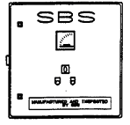

Spare Sheave: (Direct driven, expected RPM 350 – 420) Spare Belt: none

